General Requirements

Supplier
- The supplier must have obtained the ISO 9001:2015 standard
- The supplier must demonstrate its experience by providing the information regarding of test equipment installed in other PTI inspection centres. Previous experience in Georgia will be well valued.
- The supplier must guarantee the after sales service (calibrations if necessary, maintenance, repairing and spare parts supplying) during all the “Premium Rezidence” contract.
- The supplier must be able to calibrate (or train “PR” staff, provide the manuals) the following equipment (and provide standard elements):
  - Petrol exhaust gas analyser
  - Diesel exhaust gas analyser
  - Head light tester
  - Side slip tester
  - Shock absorber tester
  - Roller brake tester (including scale)
- The supplier will provide:
  - Technical and operational manuals
  - Preventive maintenance instructions
  - Calibration instructions & Full equipment, software, keys
  - In service checks instructions

Test Equipment
- All testing equipment offered in this RFP shall be accurate, reliable, and built to good engineering standards and incorporate the most up to date safety features.
- Certificates (Certificates /declaration - in case of European equipment) of conformity to the European CE standards or to Swiss, Canadian, American or Japanese standards.
- All test equipment offered must be already installed in other inspection centres with good results in terms of reliability and accuracy.
- The data measured by the following equipment shall be automatically transmitted to the central server in a corresponding format and protected from interference or inspection and/or control of the inspector:
  - Petrol exhaust gas analyser
  - Diesel exhaust gas analyser
  - Roller brake tester (including scale)
- All test equipment offered will be able to carry out inspections as indicated in Decree N510 and Decree N511 of the Government of Georgia (December 1, 2017) (Appendix #4). In the proposal, the supplier will attach a document guaranteeing this point.

Software
- The software proposed by the supplier will be able to perform inspections as indicated in Decree N510 and Decree N511 of the Government of Georgia (Appendix #4). In the proposal, the supplier will attach a document guaranteeing this point.
- This software has to have connection to send the data measured to other software (TCP-IP protocol, xml, file exchange…)
- The supplier has to explain the characteristics of this software, including communications and operational.

Equipment per Test Lane
The equipment per test lane will be:
- Light vehicles test lane
  - Head light tester rail mounted
  - Petrol exhaust gas analyser with RPM measuring device
  - Diesel exhaust gas analyser with oil temperature and RPM measuring device
  - Side slip tester
  - Shock absorber tester
  - Roller brake tester with scale
  - Play detector
  - Pit or lift
  - Hydraulic / pneumatic lifting jack
  - Wheel protector depth meter
  - Wheel supporting wedges
  - Low voltage inspection light
  - Crowbar
  - Measuring tape
  - Manometer
- Universal vehicles test lane
  - Head light tester rail mounted
  - Petrol exhaust gas analyser
  - Diesel exhaust gas analyser with oil temperature measuring device
  - Side slip tester
  - Shock absorber tester
  - Roller brake tester with scale
  - Play detector
  - Pit or lift
  - Hydraulic / pneumatic lifting jack
  - Wheel protector depth meter
  - Wheel supporting wedges
  - Low voltage inspection light
  - Crowbar
  - Measuring tape
  - Manometer
- Universal mobile unit
  - Head light tester
  - Petrol exhaust gas analyser
  - Diesel exhaust gas analyser with oil temperature measuring device
  - Side slip tester
  - Shock absorber tester
  - Roller brake tester with scale
  - Play detector
  - Hydraulic / pneumatic lifting jack
  - Wheel protector depth meter
  - Wheel supporting wedges
  - Low voltage inspection light
  - Crowbar
  - Measuring tape
  - Manometer
  - Decelerometer
  - Noise meter
  - Office
  - Power generator
The equipment per inspection centre will be:
- Decelerometer
- Noise meter
- Temperature Gun Infrared Thermometer
- Steering gap measurer
- Pedal force meter
- Glass transparency meter
- Manometer set for HV
- Tahograph /speed limiter tester (Where Universal test lane exists)
- Air compressor
NOTE: regarding shock absorber testers, in this first phase, only frames and covers will be installed. Shock absorbers will be installed afterwards if needed. The shock absorber’s test equipment price indicated in this proposal will not be modified by the supplier during the next 3 years.

Stages

Stages
The test equipment will be installed in the inspection centres in 3 different stages per test lane:
- Stage1:
  - Head light tester
  - Petrol exhaust gas analyser
  - Diesel exhaust gas analyser with oil temperature measuring device
- Stage 2:
  - Side slip tester
  - Shock absorber tester
  - Roller brake tester with scale
- Stage 3:
  - Play detector or Lift

Hardware
Every stage will be supplied with cabinet and hardware. This hardware will be:
- Computer with keyboard and a mouse
- Touch monitor
The minimum requirements for this hardware will be:
- Computer:
  - Windows 10
  - i5 processor or similar
  - 4 Gb RAM
  - HDD 500 Gb
  - 6 USB ports
  - 2 COM serial ports
  - 1 PCI Express slot
  - 1 Ethernet port

Number of inspection centres and test lanes

LOT N1
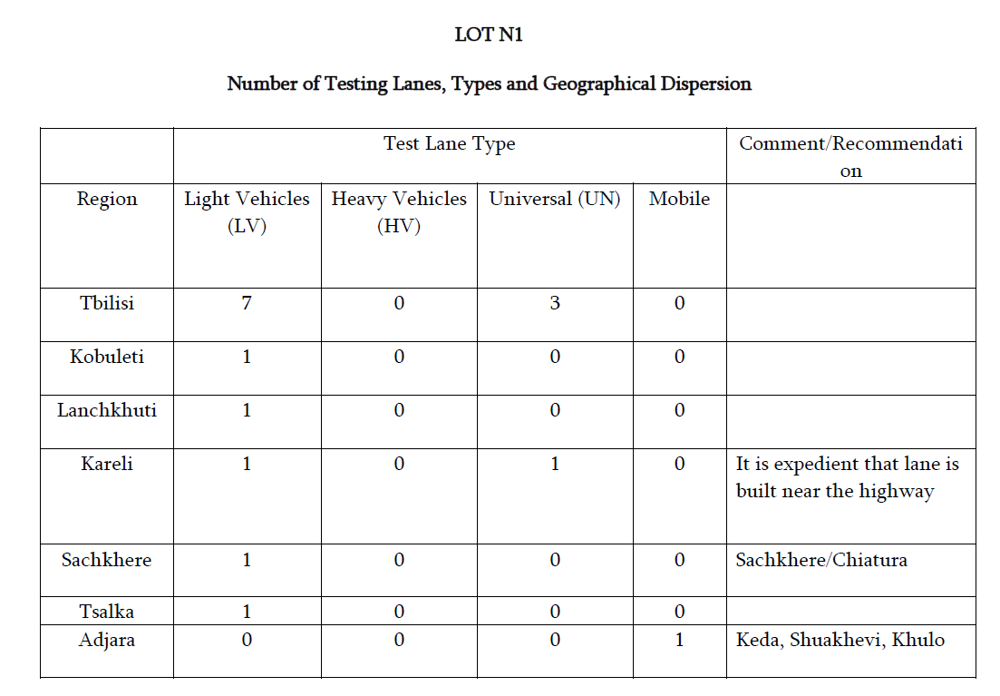

LOT N2
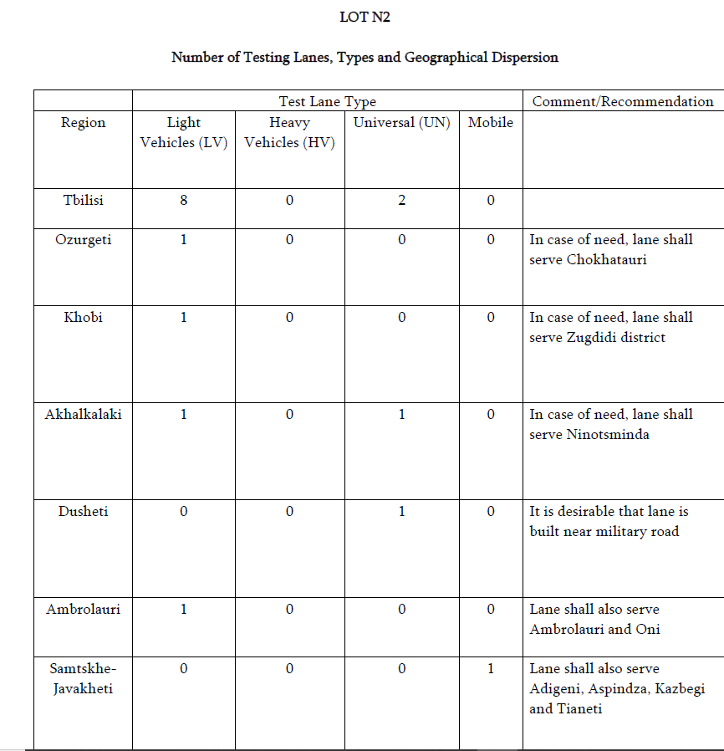

LOT N3

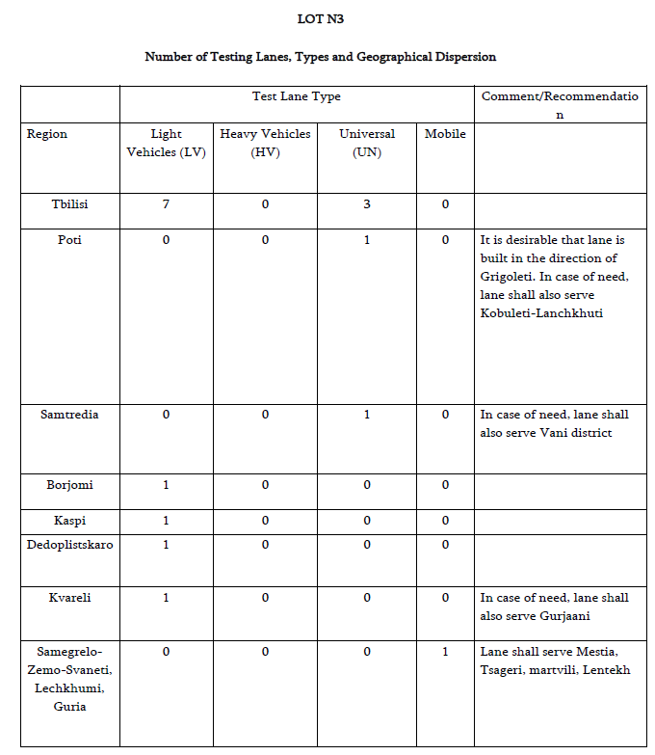

Test Equipment Summary

See quantities appendix #3.
NOTE: In orange, number of test lanes per city. In “Others”, one set per inspection centre.
LV Pit: Light vehicles test lane with pit
LV Lift: Light vehicles test lane with lift
Universal + Extr. +Lift: Universal test lane with a roller brake tester with extrapolation method (ISO 21069) and lift
Others: other test equipment
Mobile Unit: Universal mobile unit

Test Equipment technical requirements

Test Equipment | Technical requirements
Head light tester rail mounted | - In accordance with the provisions for the setting of headlights of motor vehicles (Directive 76/756/EEC)  - The light/dark boundary must be easily recognisable in daylight (without direct sunlight)  - Rail length: 2,5m  - Height range: 0,5 – 1,22 m  - Autonomy : 10h  - Rabattement : -6/+6 %  - Lateral : -10/+10 %  - Yall angle : -90/+90°  - Roll angle : -90/+90°  - Intensity : lux 0/200lx - Candela 0/125000cd  - Accuracy : Lux 5%
Petrol exhaust gas analyser | - In accordance with Directive 2004/22/EC of the European Parliament and of the Council  - Measurement of CO, HC and Lambda  - RPM measurement  - CO measurement range: 0 – 15 Vol%  - CO measurement accuracy: 0,01  - CO measurement resolution: 0,01  - HC measurement range: 0 – 2000 ppm (hexane), 0-4000 ppm (propane)  - HC measurement accuracy: 15 ppm  - HC measurement resolution: 0,1 ppm  - Lambda measurement range: 0,5 – 9,99  - Lambda measurement accuracy: 0,01  - Lambda measurement resolution: 0,001
Diesel exhaust gas analyser with oil temperature measuring device | - Measurement of smoke opacity  - RPM measurement  - Engine temperature measurement  - Opacity measurement range: 0 – 100%  - Absorption coefficient range : 0 – 9,9 m⁻¹  - RPM measurement range: 500 – 8000 rpm  - Oil temperature: 0 – 150ºC
Side slip tester (Light vehicles) | - Minimum axle load: 2,6 t  - EC Approval  - Measurement range: 0 – 20 m/km
Side slip tester (Installed in Universal test lanes) | - Minimum axle load: 15 t  - EC Approval  - Measurement range: 0 – 20 m/km
Shock absorber tester (Light vehicles) | - Minimum test axle load: 2 t  - Minimum axle load (pass): 2,5 t  - EC Approval
Shock absorber tester (Universal test lanes) | - Minimum test axle load: 2 t  - Minimum axle load (pass): 16 t  - EC Approval
Roller brake tester with scale (Motorbikes) | - Weighing device  - Permissible axle load: 1 t  - Test speed: approx. 5 km/h  - Drive power: 2,5 kW  - Measurement value display: 0 – 3 kN  - Plastic coated roller surface
Roller brake tester with scale (Light vehicles) | - Weighing device  - Permissible axle load: 5t  - Test speed: approx. 5 km/h  - Drive power: 2 x 4 kW  - Measurement value display: 0 – 6 kN  - Plastic coated roller surface
Roller brake tester with scale (Heavy vehicles) | - Weighing device  - Permissible axle load: 18 t  - Test speed: approx. 3 km/h  - Drive power: 2 x 11 kW  - Measurement value display: 0 – 40 kN  - Plastic coated roller surface  - Must comply with ISO 21069-1 (3 sensors - 1 point calculation method).  - Minimum lift height: 200 mm
Play detector (Light vehicles) | - Minimum axle load: 2,6 t  - 4 movements (longitudinal and transversal)
Play detector (Heavy vehicles) | - Minimum axle load: 15 t  - 4 movements (longitudinal and transversal)  - Minimum longitudinal and transversal movement: 95 mm,  - Movement speed: from 5 cm/s to 15 cm/s
Lift | - Minimum length: 3,9 m (doesn’t include ramp length)  - No parts of the lifting platform shall be raised above the line surface at more than 25 mm  - Minimum height lifting: 1,4 m  - Minimum width between the inner platform edges: 0,7 m  - Minimum width between the outer platform edges: 2,1 m  - Minimum safe carrying capacity: 3,5 t  - Axle lifting jack with minimum recommended carrying capacity: 2,6 t  - Minimum jack lifting height: 450 mm
Hydraulic / pneumatic lifting jack (Light vehicles) | - Safe carrying capacity: 2,6 t  - Minimum jack lifting height: 450 mm
Hydraulic / pneumatic lifting jack (Heavy vehicles) | - Safe carrying capacity: 15,0 t  - Minimum jack lifting height: 450 mm
Wheel protector depth meter | - Minimum measuring distance: 2,5 mm  - Resolution: 0.1 mm
Wheel supporting wedges | - 4 units  - For heavy vehicles
Low voltage inspection light | - Less than 36V  - External protection  - Cable shall not be in contact with the floor
Crowbar
Measuring tape
EOBD reader | - Complying with Spanish regulations
Gas Leak detector | - Able to detect LPG/CNG/LNG.
Manometer | - Measurement range: 0 - 12 bars
Decelerometer | - Measurement range: - 15 to +15 m/s2  - While non continuous measurement must record/store measurements at least 10 times per second
Noise meter | - Class II sound level meter
Infrared thermometer | - Minimum range: 50ºC to 120ºC
Steering gap measurer | - Resolution: less than 1º
Glass transparency meter | - Measurement range: from less than 35% to more than 80%
Speed limiter tester | - Resolution: 1 km/h  - Measurement range: 10 km/h – 160 km/h  - Determination of k value
Some variations in the Test Equipment requirements (except Government of Georgia requirements) could be accepted if are properly justified by the supplier.

After sales / Maintenance contract
The supplier will offer an after sales and maintenance contract indicating:
- Duration of the contract
- Resources
  - Facilities, vehicles,…
  - Staff (indicating if a branch or a dealer)
- Prices of new test equipment and their evolution during all the contract
- Prices of the main spare parts and their evolution during all the contract
- All prices related with the maintenance contract
- Response times in case of failure
  - Maximum time to attend the failure
  - Maximum time to solve the failure
- Calibration prices
- Warranty period / Warranty conditions
- The nearest Official Dealer/partner – service provider
- AS staff/technicians certificates and proof documents of qualification
- Buffer stock of spear parts volume

Financial offers

Leasing
The supplier will indicate leasing conditions if available. Lease term: minimum 5 years maximum 10 years.

Other

In case the supplier has other credit terms, these will be included in the proposal.

